A000-ME-Persia-Rhyton-Bovid-Amlash-Terra cotta-500 BCE

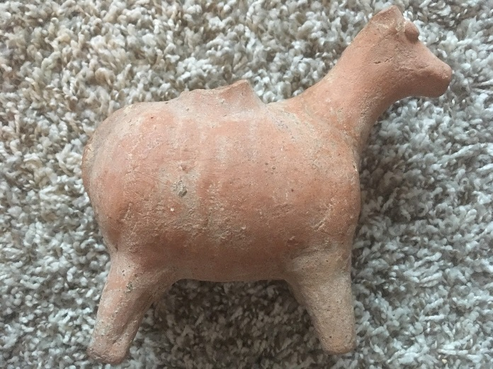 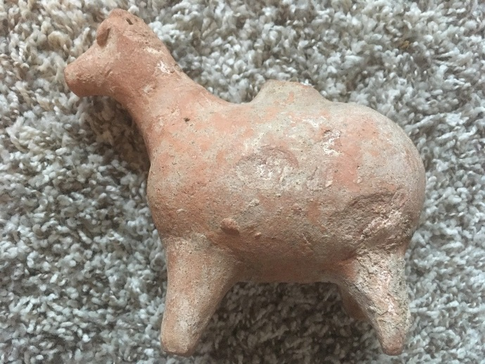 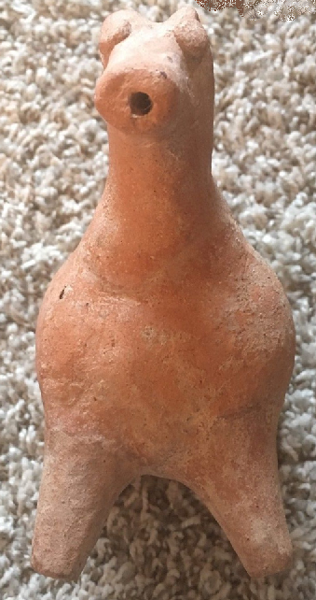 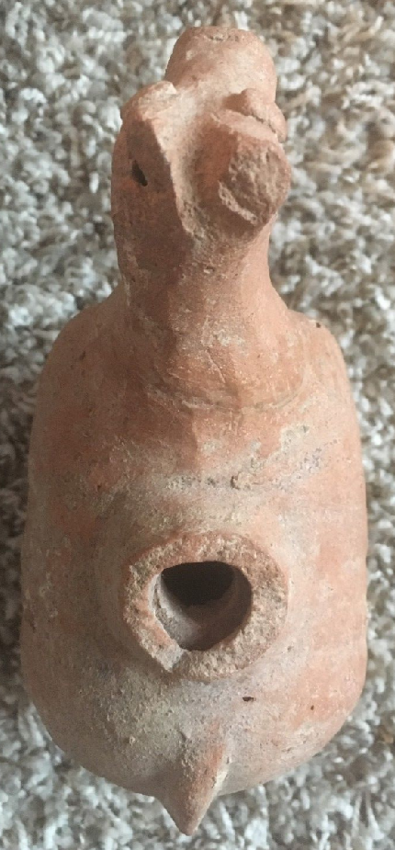 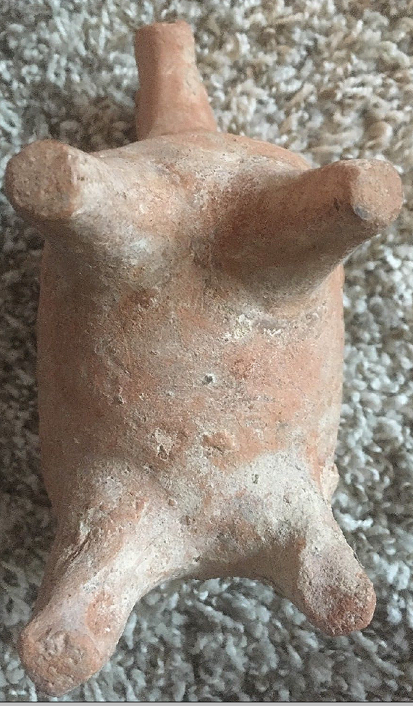

Figs. 1-5. ME-Persia-Rhyton-Bovid-Amlash-Terra cotta-500 BCE

**Case no.: 3**

**Accession Number:**

**Formal Label:** ME-Persia-Rhyton-Bovid-Amlash-Terra cotta-500 BCE **Display Description:**

This terra cotta bovid rhyton or libation vessel has a plump body to accommodate about ¾ of a quart of liquid with a filling hole on top and with a hollow snout for drinking. It is associated with the so-called “Amlash (Amlaš) Culture,” which is named after a small village in southeastern Gīlān Province of ancient Persia (i.e., modern Iran) adjacent to the Alborz Mountain valleys. While the use of “Amlash Culture” has been opposed on the grounds that the artifacts from western Persia are too varied and without provenance, it is apparent that these rhyta comprise a consistent artefactual trait over many centuries spanning the second and first millennia BCE that implies a scientifically discernible cultural identity. The name, “Amlash Culture,” was created in 1961 for an exhibition to denote a mid-first millennium BCE culture that appeared to have a relatively uninterrupted ceramic tradition of producing bovid rhyta (sing. rhyton) which were ceremonial libation vessels. The earliest discovery of these so-called Amlash artifacts was made in the Kalār Dašt area of Māzandarān where bronze, gold, and pottery objects were found in 1934 (Samadi 1959). Further finds were made near the villages of Tomaǰān, Emām, and Garmābak in 1954 (Samadi 1959).

In the period from the second to the first millennium BCE the color of these Amlash rhyta shifted from black to grey to buff and orange, a change that was related to the increase in temperature used in pottery kilns that amplified the oxidation level and therefore altered the color of the fired ceramics. Reasons for this increased temperature may have been related to the need of increased production of pottery as populations expanded and so kilns were fired rather continuously with increasing temperatures to produce ceramics faster and in greater quantities to meet a growing demand. The current example of a bovid rhyton exemplified this color change by being orange in color, thereby indicating it was fired at a relatively high temperature (c 1000 degrees F) which suggests late dating of the mid first millennium BCE.

Therefore, probably the color change in these rhyta was related not only to a technical aspect of pottery production but also to a demographic development, but the iconography of bovid representation remained relatively constant.  This spectrum of a pottery color shift was confirmed by excavations at Mārlīk (Negahban 1968) and at Daylamān (Egami *et al.* 1965-1971) where rhyta were archaeologically excavated in rock-lined tombs. Since the animals represented in these rhyta were mainly bovids, it is suggested that there was a specific sedentary, cattle-rearing “Amlash Culture” that extended from the late second millennium BCE to the Partho-Sasanian period.

Since rhyta are not utilitarian but ritual drinking vessels embodying a revered aspect of a culture, they were used for libations honoring livestock -- the main source of Amlash wealth -- and they symbolize the central figure of this quasi-nomadic, western Persian livestock culture. A further evolution of this cattle-rearing “Amlash Culture” evolved in the Partho-Sassanian period when agriculture was developed in these western Persian valleys along with livestock-rearing. During the initial expansion of Islam, Muslims, from the west, viewed this culture area as a prize to be conquered (Wenke 1987) as recorded by al-Ṭabarī in his enormous book, *Ta'rīkh al-rusul wa 'l-mulūk*, a universal history from the seventh c to 915 CE. With this brutal conquest the spirituality of the Amlash and their rhyta come to an end.

**LC Classification:**

**Date or Time Horizon:** 500 BCE

**Geographical Area:** western Persia

**Map:**

**GPS coordinates:**

**Cultural Affiliation:**

**Medium:**

**Dimensions:**

**Weight:**

**Condition:**

**Provenance:** Ex Private NY Collector

**Discussion:**

**References:**

Prominent Rounded Features, the Muzzle Extending into the Spout

Approx. 6.5" x 5.5"

al-Ṭabarī. 1994. *The History of al-Ṭabarī (Ta'rīkh al-rusul wa 'l-mulūk): The Conquest of Iran*, trans. G. Rex Smith. New York: State University of New York Press.

Egami, N. *et al*., 1965-71. Dailaman I-IV. Tokyo: Institute of Oriental Culture, University of Tokyo.

Hakemi, A. 1968. “Kaluraz and the Civilization of the Mardes,” Archaeologia Viva 1: 63-65.

Negahban, E. O. 1964. A Preliminary Report on the Marlik Excavation. Tehran.

Samadi, H. 1959. “Les découvertes fortuites de Kalar Dasht, Garmabak, Emam et Tomadjan (Mazanderan et Gilan),” Arts Asiatiques 6: 175ff.

Wenke, R.J., 1987. “Western Iran in the Partho-Sasanian period: the imperial transformation.” In F. Hole, ed., *The archaeology of western Iran: Settlement and Society from Pre-history to the Islamic Conquest*. Smithsonian Series in Archaeological Inquiry. Washington, DC: Smithsonian Institution Press, pp. 251-281.